dp_mat = "C:\Users\ZE322385.ZEDC\Documents\dp_impedance\resultsdp.mat";
tr_mat = "C:\Users\ZE322385.ZEDC\Documents\tr_impedance\resultstr.mat";

---------------- Targets / policy knobs ----------------
f0 = 0.44; % inter-area target [Hz]
fp = 0.44; % PSS design center [Hz]
fh = 0.44; % HVDC design center [Hz]
% RATIO SEMANTICS: ratio = |Lhvdc| / |Lpss| must be >= rho_target at f0
rho_target = 1.20; % want HVDC to dominate at f0
ReL_min = 1.5; % desired Re{Lsum}(f0) for info/prints (not hard)
phasegap_ok = 12; % desired |∠(Lpss)-∠(Lhvdc)| at f0 [deg] (info only)
% Optimizer settings
epsilon_band = 0.05; % damping floor over band (0.30–1.50 Hz)
band_lo_hi = [0.30, 1.50];
w1 = 10.0; % reward weight for Re{Lsum}(f0)
w2 = 8.0; % penalty weight for ratio < rho_target
w3 = 6.0; % penalty weight for crossing < f0
w4 = 1.0; % penalty weight for bandwise Re{Lsum} < epsilon_band
reg_w = 1e-3;% normalized, weighted regularizer strength
w_par = [1, 1, 0.5, 0.5];
% Gain dB caps for the optimizer
dKpss_lb = -6; dKpss_ub = +6; % PSS ±6 dB
dKh_lb = -12; dKh_ub = 0; % HVDC trim up to −12 dB (no boost)
% Lead angle bounds
phi_min = 2;
phi_max = 80; % deg
% Normalized-regularization setup (half-ranges for [dKp, dKh, phiP, phiH])
r_half = [ (dKpss_ub - dKpss_lb)/6, ...
(dKh_ub - dKh_lb )/6, ...
(phi_max - phi_min )/21.5, ...
(phi_max - phi_min )/21.5 ];
r_half(r_half < 1e-9) = 1e-9; % guard
fprintf('\n[Regularizer] reg_w=%.3e, w_par=[%.1f %.1f %.1f %.1f]\n', reg_w, w_par);
fprintf('[Ratio] |L_H|/|L_P| ≥ rho_target = %.3f at f0\n\n', rho_target);
tag = datestr(now,'yyyymmdd_HHMMSS');
[Regularizer] reg_w=1.000e-03, w_par=[1.0 1.0 0.5 0.5]
[Ratio] |L_H|/|L_P| ≥ rho_target = 1.200 at f0

---------------- Network, machine, control blocks ----------------
i = 2; j = 3; % generator bus (PSS), HVDC injection bus
Ybus = [ 0.11098779-3.32963374*1i, -0.11098779+3.32963374*1i, 0+0*1i;
-0.11098779+3.32963374*1i, 0.27073220-7.52324396*1i, -0.15974441+3.99361022*1i;
0+0*1i, -0.15974441+3.99361022*1i, 0.15974441-3.99361022*1i ];
E = [1.00; 1.00; 1.01];
delta = deg2rad([0; 20; 5]);
H_M = 6.5; D_M = 0.001;
KA = 20; TA = 0.001;
Twash_PSS = 10;
Twash_HVDC = 5;
Td = 0.2;

---------------- Load measured impedances (or auto-generate) ----------
haveFiles = exist(dp_mat,'file')==2 && exist(tr_mat,'file')==2;
if haveFiles
dpresults = load(dp_mat); trresults = load(tr_mat);
assert(isfield(dpresults,'resultsdp') && isfield(trresults,'resultstr'), ...
'MAT files must contain variables resultsdp and resultstr.');
Tdp = dpresults.resultsdp;
Ttr = trresults.resultstr;
else
fprintf('** No MAT files found. Using self-generated demo data. **\n');
f_demo = linspace(0.05, 2.0, 400).';
% Driving-point impedance (ohms): mag decays with f, small inductive angle
Zmag_dp = 2.5 ./ (1 + (f_demo/0.5).^1.2);
Zang_dp = 30 - 25*atan(f_demo/0.7)/ (pi/2); % degrees
% Transfer impedance: small coupling with mild resonance near 0.45 Hz
Zmag_tr = 0.15 + 0.18*exp(-((f_demo-0.45)/0.12).^2);
Zang_tr = -20 + 35*exp(-((f_demo-0.45)/0.18).^2);
Tdp = table(f_demo, Zmag_dp, Zang_dp, 'VariableNames', {'f','Zmag','Zang'});
Ttr = table(f_demo, Zmag_tr, Zang_tr, 'VariableNames', {'f','Zmag','Zang'});
end
% Inline extraction of f/Z columns (supports table or struct)
if istable(Tdp), f = Tdp.f; Zmagdp = Tdp.Zmag; Zangdp = Tdp.Zang;
else, f = Tdp.f; Zmagdp = Tdp.Zmag; Zangdp = Tdp.Zang; end
if istable(Ttr), Zmagtr = Ttr.Zmag; Zangtr = Ttr.Zang;
else, Zmagtr = Ttr.Zmag; Zangtr = Ttr.Zang; end
toRad = @(x) x*(pi/180);
if max(abs(Zangdp)) > pi, angdp = toRad(Zangdp); else, angdp = Zangdp; end
if max(abs(Zangtr)) > pi, angtr = toRad(Zangtr); else, angtr = Zangtr; end
angdp = unwrap(angdp(:)); angtr = unwrap(angtr(:));
Zii = Zmagdp(:).*exp(1i*angdp);
Zij = Zmagtr(:).*exp(1i*angtr);
[w_raw, ix] = sort(2*pi*f(:), 'ascend'); % f_raw = w_raw/(2*pi);
Zii = Zii(ix); Zij = Zij(ix);
V = E.*exp(1i*delta);
I0 = Ybus*V;
% Build FRD blocks directly from measured (or demo) data
Yin = 1./Zii;
Tijv = real( conj(I0(i)) .* Zij .* exp(1i*delta(j)) )/E(j);
Niiv = real( conj(I0(i))*exp(1i*delta(i)) ) + E(i)*real(Yin);
Tij = frd(reshape(Tijv,1,1,[]), w_raw);
Nii = frd(reshape(Niiv,1,1,[]), w_raw);

---------------- Build control/plant blocks ----------------
s = tf('s'); % ensure 's' exists before use
G_rot = frd( 1/(2*H_M*s + D_M), w_raw );
G_AVR = frd( KA/(1 + s*TA), w_raw );
G_wP = frd( (s*Twash_PSS)/(1 + s*Twash_PSS), w_raw );
G_wH = frd( (s*Twash_HVDC)/(1 + s*Twash_HVDC), w_raw );
if exist('pade','file')==2 && Td>0
[numD,denD] = pade(Td,1);
G_dly = frd(tf(numD,denD), w_raw);
else
G_dly = frd(tf(1,1), w_raw);
end
baseP = (G_wP*G_AVR)*Nii*(G_rot); % PSS pathway
baseH = (G_wH*G_dly)*Tij*(G_rot); % HVDC pathway

---------------- Initial leads at centers & initial gains -------------
degf = @(x) (180/pi)*x;
wP = 2*pi*fp; wH = 2*pi*fh;
[~,kP] = min(abs(w_raw - wP));
[~,kH] = min(abs(w_raw - wH));
GP0 = squeeze(freqresp(baseP, w_raw(kP)));
GH0 = squeeze(freqresp(baseH, w_raw(kH)));
phiP = max(min(degf(pi - angle(GP0)),phi_max),phi_min);
aP = (1+sind(phiP))/(1-sind(phiP));
TzP = sqrt(aP)/wP; TpP = 1/(wP*sqrt(aP));
LeadP = frd((1+s*TzP)/(1+s*TpP), w_raw);
phiH = max(min(degf(pi - angle(GH0)),phi_max),phi_min);
aH = (1+sind(phiH))/(1-sind(phiH));
TzH = sqrt(aH)/wH; TpH = 1/(wH*sqrt(aH));
LeadH = frd((1+s*TzH)/(1+s*TpH), w_raw);
CP0 = squeeze(freqresp(LeadP, w_raw(kP)));
CH0 = squeeze(freqresp(LeadH, w_raw(kH)));
Kpss0 = 1/max(abs(GP0*CP0),eps); % nominal gains (pre-trim)
Kh0 = 1/max(abs(GH0*CH0),eps);

---------------- Frequency sweep & utilities --------------------------
f_sweep = (0.01:0.01:2.0).'; w_sweep = 2*pi*f_sweep;
[~,k0] = min(abs(f_sweep - f0));
bandMask = (f_sweep>=band_lo_hi(1) & f_sweep<=band_lo_hi(2));
freqresp_sweep = @(G) squeeze(freqresp(G, w_sweep));
magdb = @(x) 20*log10(max(abs(x),eps));
epsz = 1e-12;
LP_fac = (G_wP*LeadP*G_AVR) * Nii * (G_rot);
LH_fac = (G_wH*LeadH*G_dly) * Tij * (G_rot);
PSSloop = G_AVR*Nii*(G_rot)
HVDCloop = Tij*(G_rot)
fmin = 0.01; fmax = 2.0; Npts = 200;
f = linspace(fmin,fmax,Npts).';
w = 2*pi*f;

============================================================
PART A: OPTIMIZED LOOP TRANSFER FUNCTIONS (tf -> freqresp)

============================================================
% ---------- Define s and your optimized controllers ----------
s = tf('s');
% >>> REPLACE THESE with your tuned controller structures <<<
% Example controller (washout + lead/lag):
Tw = 10; T1 = 0.2; T2 = 0.02; Kpss = 15;
C11 = Kpss * (Tw*s)/(1+Tw*s) * (1+T1*s)/(1+T2*s); % "Loop 11" controller
Khdc = 5; T3 = 0.3; T4 = 0.03;
C22 = Khdc * (Tw*s)/(1+Tw*s) * (1+T3*s)/(1+T4*s); % "Loop 22" controller
% ---------- Define your identified plants ----------
% >>> REPLACE with your identified transfer functions G11(s), G22(s) <<<
% If you already have them in the workspace, comment these examples.
G11 = 1/(s^2 + 0.4*s + 4); % example only
G22 = 0.7/(s^2 + 0.35*s + 3.2); % example only
G11 = G11;
G22 = G22;
% ---------- Optimized loop TFs ----------
Lopt11_tf = minreal(C11 * G11);
Lopt22_tf = minreal(C22 * G22);
% ---------- Evaluate L_opt(jw) ----------
Lopt11 = squeeze(freqresp(Lopt11_tf, w)); Lopt11 = Lopt11(:);
Lopt22 = squeeze(freqresp(Lopt22_tf, w)); Lopt22 = Lopt22(:);

============================================================
PART B: CALCULATED LOOPS FROM IMPEDANCE-BASED FRAMEWORK (FRD)

============================================================
% You must provide Lcalc11(jw) and Lcalc22(jw) as complex vectors
% on the SAME frequency grid 'f' (or interpolate them).
% >>> OPTION B1: load from MAT file (recommended) <<<
% Expected fields: FRD.f_Hz, FRD.Lcalc11, FRD.Lcalc22
% load('LoopFRD_Calculated.mat','FRD');
% Lcalc11_raw = FRD.Lcalc11(:);
% Lcalc22_raw = FRD.Lcalc22(:);
% f_raw = FRD.f_Hz(:);
% >>> OPTION B2: If you stored impedance-derived coupling Nii, Tij etc. <<<
% Example: Lcalc11 = C11(jw)*Nii(jw)*Grot(jw)
% Example: Lcalc22 = C22(jw)*Tij(jw)*Grot(jw)
%
% For now, create placeholders to avoid crashing:
Lcalc11_raw = loopPSS; % <-- REPLACE
Lcalc22_raw = loopHVDC; % <-- REPLACE
f_raw = f;
% Interpolate calculated loop onto f grid if needed
if any(f_raw ~= f) || numel(f_raw) ~= numel(f)
Lcalc11 = interp1(f_raw, Lcalc11_raw, f, 'linear', 'extrap');
Lcalc22 = interp1(f_raw, Lcalc22_raw, f, 'linear', 'extrap');
else
Lcalc11 = Lcalc11_raw;
Lcalc22 = Lcalc22_raw;
end

============================================================
PART C: PLOTS (Overlay + error)

============================================================
magdb = @(x) 20*log10(max(abs(x),1e-12));
phdeg = @(x) unwrap(angle(x))*180/pi;
% --------- Loop 11 Bode overlay ----------
figure('Color','w','Units','centimeters','Position',[3 3 18 11]);
tiledlayout(2,1,'TileSpacing','compact','Padding','compact');
nexttile; hold on; grid on; box on;
plot(f, magdb(Lopt11), 'LineWidth',1.5);
plot(f, magdb(Lcalc11),'--','LineWidth',1.5);
xlim([0 2]);
ylabel('|L_{11}(j\omega)| (dB)');
title('Loop 11: Optimized vs Calculated (0–2 Hz)');
legend('L_{opt,11}','L_{calc,11}','Location','best');
nexttile; hold on; grid on; box on;
plot(f, phdeg(Lopt11), 'LineWidth',1.5);
plot(f, phdeg(Lcalc11),'--','LineWidth',1.5);
xlim([0 2]);
xlabel('Frequency (Hz)');
ylabel('Phase (deg)');
% --------- Loop 22 Bode overlay ----------
figure('Color','w','Units','centimeters','Position',[3 3 18 11]);
tiledlayout(2,1,'TileSpacing','compact','Padding','compact');
nexttile; hold on; grid on; box on;
plot(f, magdb(Lopt22), 'LineWidth',1.5);
plot(f, magdb(Lcalc22),'--','LineWidth',1.5);
xlim([0 2]);
ylabel('|L_{22}(j\omega)| (dB)');
title('Loop 22: Optimized vs Calculated (0–2 Hz)');
legend('L_{opt,22}','L_{calc,22}','Location','best');
nexttile; hold on; grid on; box on;
plot(f, phdeg(Lopt22), 'LineWidth',1.5);
plot(f, phdeg(Lcalc22),'--','LineWidth',1.5);
xlim([0 2]);
xlabel('Frequency (Hz)');
ylabel('Phase (deg)');
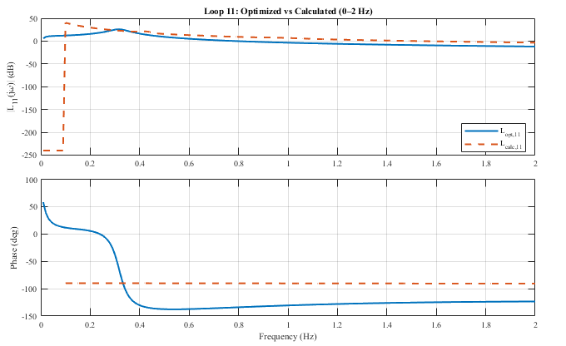
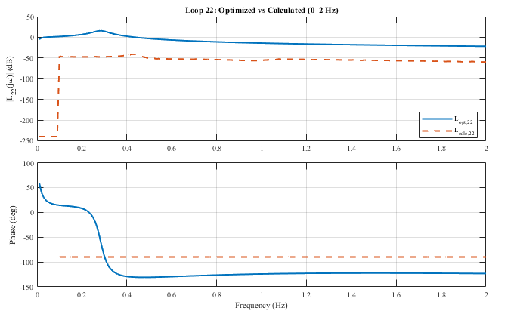

---------------- Error metrics (optional) ------------------
magErr11_pct = 100*(abs(Lcalc11)-abs(Lopt11))./max(abs(Lopt11),1e-12);
magErr22_pct = 100*(abs(Lcalc22)-abs(Lopt22))./max(abs(Lopt22),1e-12);
phErr11 = phdeg(Lcalc11) - phdeg(Lopt11);
phErr22 = phdeg(Lcalc22) - phdeg(Lopt22);
figure('Color','w','Units','centimeters','Position',[3 3 18 9]);
tiledlayout(2,2,'TileSpacing','compact','Padding','compact');
nexttile; stem(f, magErr11_pct,'filled'); grid on; box on; xlim([0 2]);
title('Loop 11 |L| error'); xlabel('Hz'); ylabel('%');
nexttile; stem(f, phErr11,'filled'); grid on; box on; xlim([0 2]);
title('Loop 11 phase error'); xlabel('Hz'); ylabel('deg');
nexttile; stem(f, magErr22_pct,'filled'); grid on; box on; xlim([0 2]);
title('Loop 22 |L| error'); xlabel('Hz'); ylabel('%');
nexttile; stem(f, phErr22,'filled'); grid on; box on; xlim([0 2]);
title('Loop 22 phase error'); xlabel('Hz'); ylabel('deg');
disp('Done: compared optimized loop TF vs calculated loop FRD (0–2 Hz).');
Done: compared optimized loop TF vs calculated loop FRD (0–2 Hz).
